Deployment of vault HA using MySQL

Introduction:

1.What is Vault?

HashiCorp Vault is an open-source tool designed to securely store, manage, and access secrets (such as API keys, passwords, certificates, and encryption keys) in modern distributed systems and cloud-native environments. It provides centralized secrets management, encryption as a service, and secure access management for any infrastructure, application, or service.

Prerequisites:
Kubernetes cluster (Minikube, EKS, GKE, etc.)
- Helm installed (v3.0+)
- MySQL deployed in Kubernetes
- kubectl installed and configured for your cluster
- MySQL connection credentials ready

Step 1: Deploy MySQL in Kubernetes
If MySQL is not already deployed, you can deploy it using the following steps:

1. Create a MySQL Kubernetes Deployment and Service:mysql.yaml

apiVersion: apps/v1
kind: Deployment
metadata:
name: mysql
spec:
replicas: 1
selector:
matchLabels:
app: mysql
template:
metadata:
labels:
app: mysql
spec:
containers:
- name: mysql
image: mysql:5.7
env:
- name: MYSQL_ROOT_PASSWORD
value: rootpassword
- name: MYSQL_DATABASE
value: vaultdb
- name: MYSQL_USER
value: vault
- name: MYSQL_PASSWORD
value: vaultpassword
ports:
- containerPort: 3306
---
apiVersion: v1
kind: Service
metadata:
name: mysql
spec:
ports:
- port: 3306
selector:
app: mysql
____________________________________________________________
2. Apply the MySQL Deployment

$kubectl apply -f mysql-deployment.yaml

3. Verify the MySQL Pod
Check if the MySQL pod is running:
$kubectl get pods
Also, check if the MySQL service is exposed:
$kubectl get svc

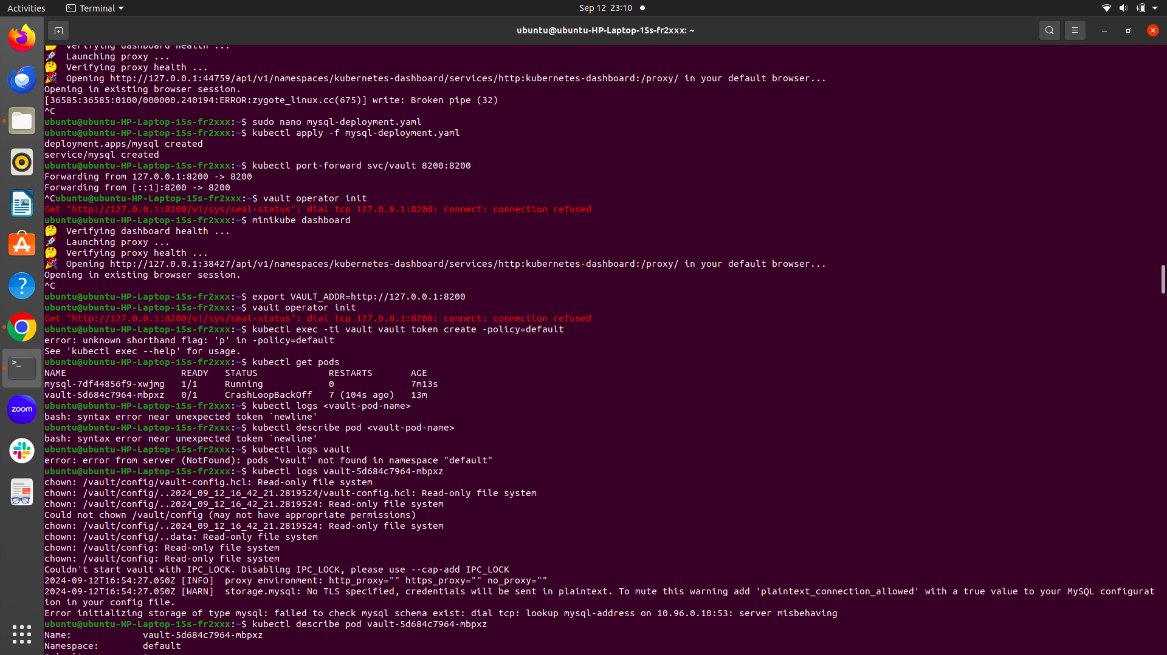
Step 2: Install Helm and HashiCorp Vault Helm Chart
1. Add the HashiCorp Helm Repository:
$helm repo add hashicorp https://helm.releases.hashicorp.com

2. Update Helm Repository
Ensure Helm repositories are updated:
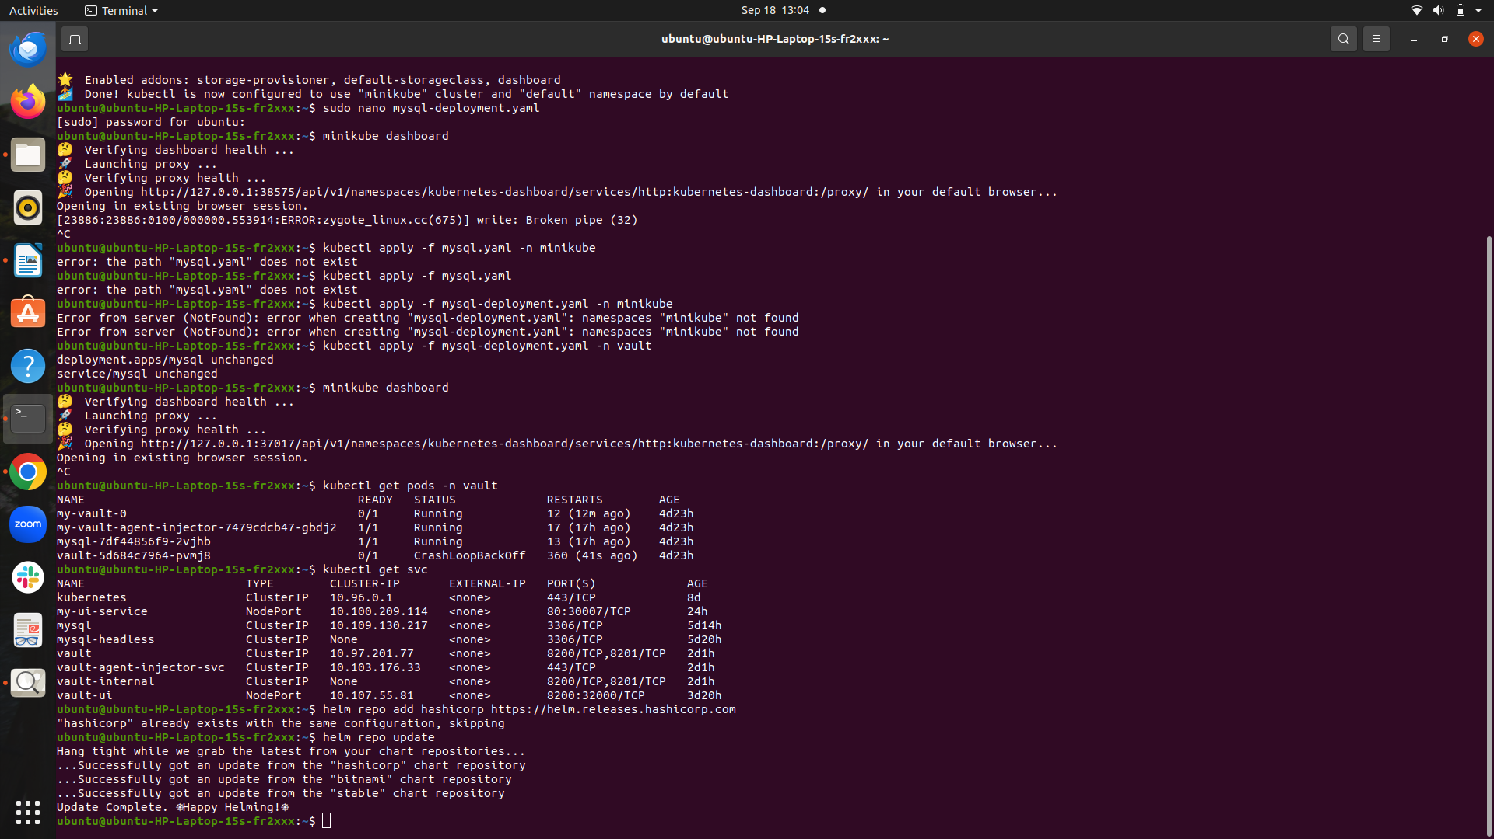
$helm repo update

3. Install Vault using Helm:
Before installation, configure a custom values file to specify the MySQL backend.
Create a vault-values.yaml file:

server:
extraEnvironmentVars:
VAULT_LOG_LEVEL: "debug"
ha:
enabled: false
storage:
mysql:
address: "mysql:3306"
username: "vault"
password:
secretRef:
name: mysql-root-password
key: password
database: "vault_db"

server:
securityContext:
capabilities:
add: ["IPC_LOCK"]
-------------------------------------------------------------
Install Vault with the custom values file:
$helm install vault hashicorp/vault -f vault-values.yaml
Verify Vault Installation
kubectl get pods
kubectl get svc
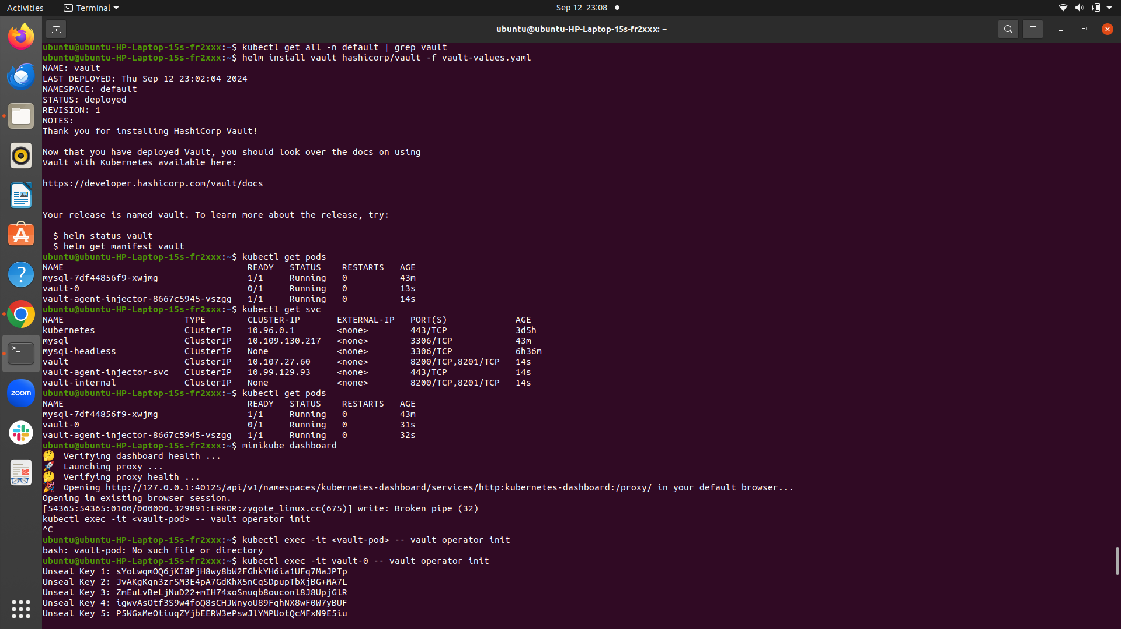
4. Deploy Vault StatefulSet deployment:

apiVersion: apps/v1
kind: StatefulSet
metadata:
name: vault
namespace: default
labels:
app: vault
spec:
serviceName: "vault"
replicas: 1
selector:
matchLabels:
app: vault
template:
metadata:
labels:
app: vault
spec:
containers:
- name: vault
image: hashicorp/vault:1.10.0
ports:
- containerPort: 8200
env:
- name: VAULT_DISABLE_MLOCK
value: "true"
volumeMounts:
- name: vault-config
mountPath: /vault/config
- name: vault-data
mountPath: /vault/data
volumes:
- name: vault-config
configMap:
name: vault-config
- name: vault-data
emptyDir: {}
volumeClaimTemplates:
- metadata:
name: vault-data
spec:
accessModes: ["ReadWriteOnce"]
resources:
requests:
storage: 10Gi
Apply the YAML to Kubernetes:
$kubectl apply -f vault-statefulset.yaml
5. create vault-ui-service.yaml

apiVersion: v1
kind: Service
metadata:
name: vault-ui
labels:
app: vault
spec:
type: NodePort # Or LoadBalancer for cloud environments
ports:
- port: 8200
targetPort: 8200
protocol: TCP
nodePort: 32000 # Use any available port
selector:
app.kubernetes.io/name: vault
Apply the YAML to Kubernetes:
$kubectl apply f vaultui-service.yaml

Step 3: Initialize and Unseal Vault
1. Initialize Vault:
$kubectl exec -it vault-0 -- vault operator init
Vault will generate unseal keys and a root token. Make sure to store these securely.
2. Unseal Vault: Use the unseal keys to unseal Vault:
kubectl exec -it vault-0 -- vault operator unseal <unseal-key-1>
kubectl exec -it vault-0 -- vault operator unseal <unseal-key-2>
kubectl exec -it vault-0 -- vault operator unseal <unseal-key-3>
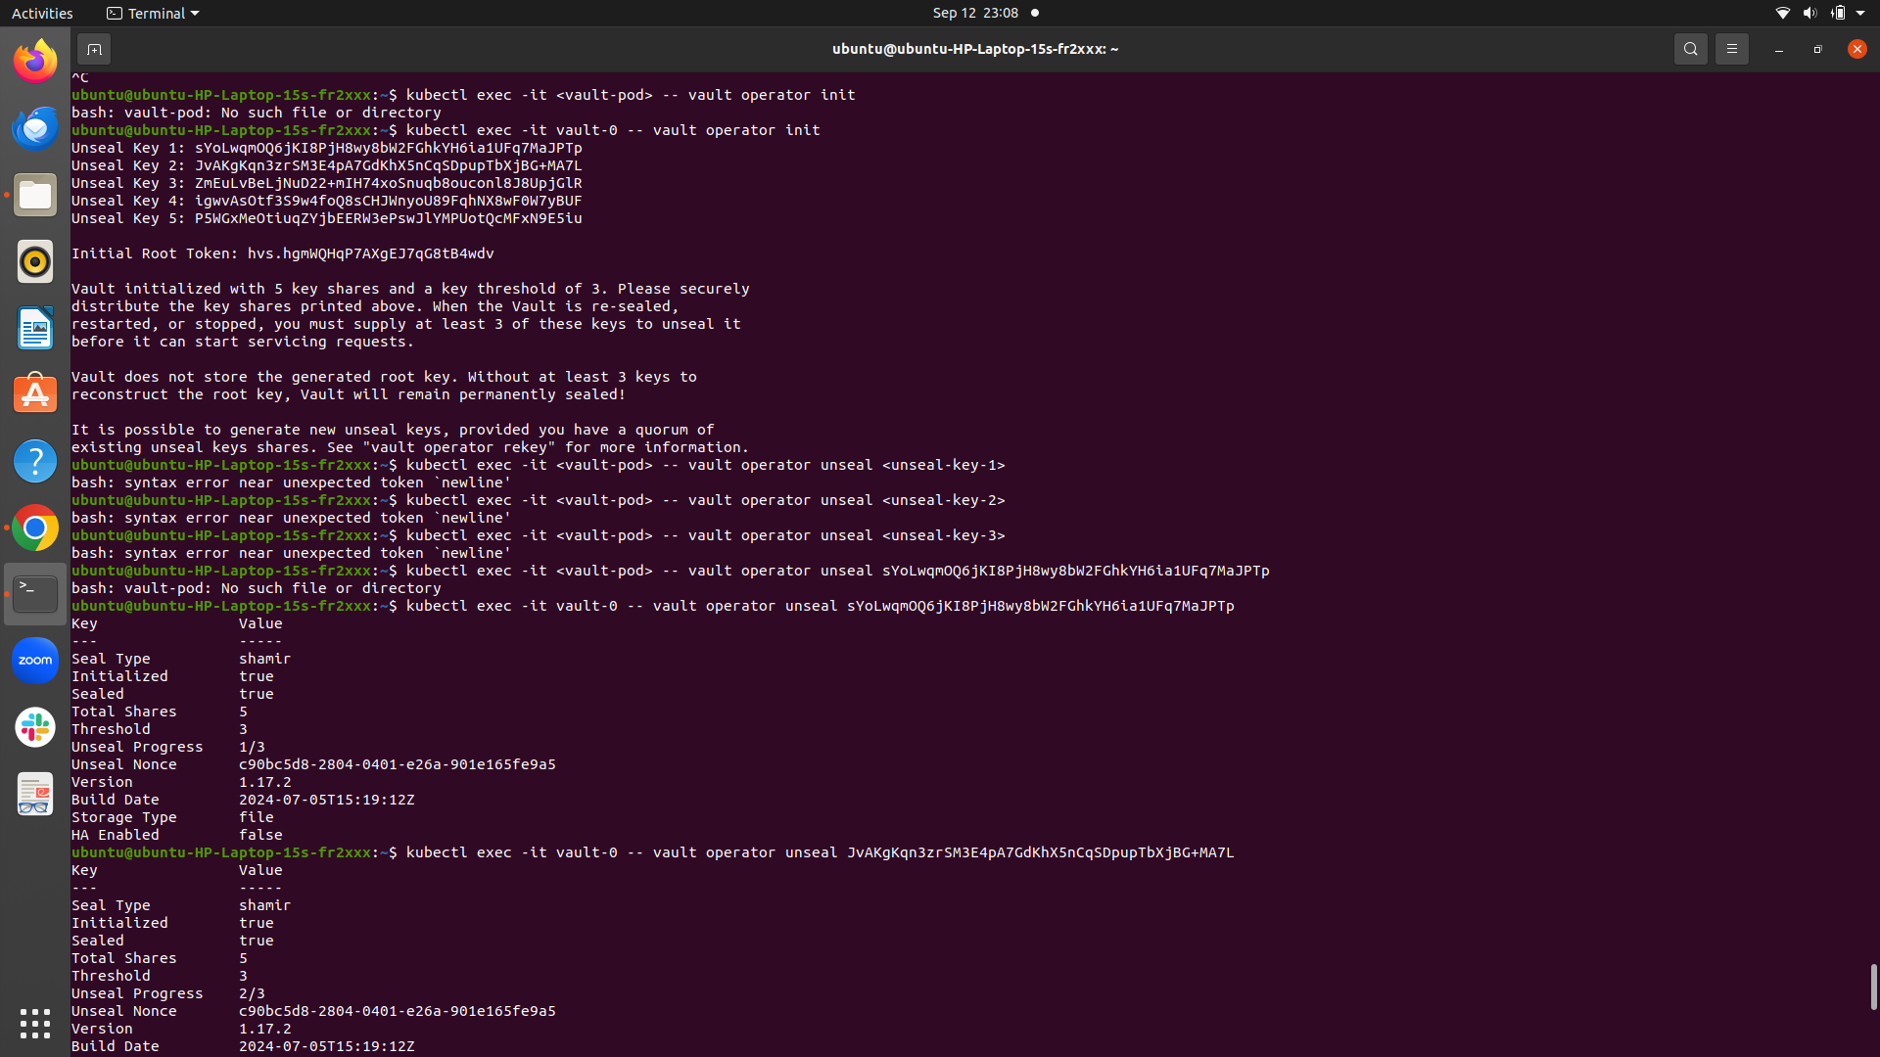
3. Verify Vault status:
$kubectl exec -it vault-0 -- vault status
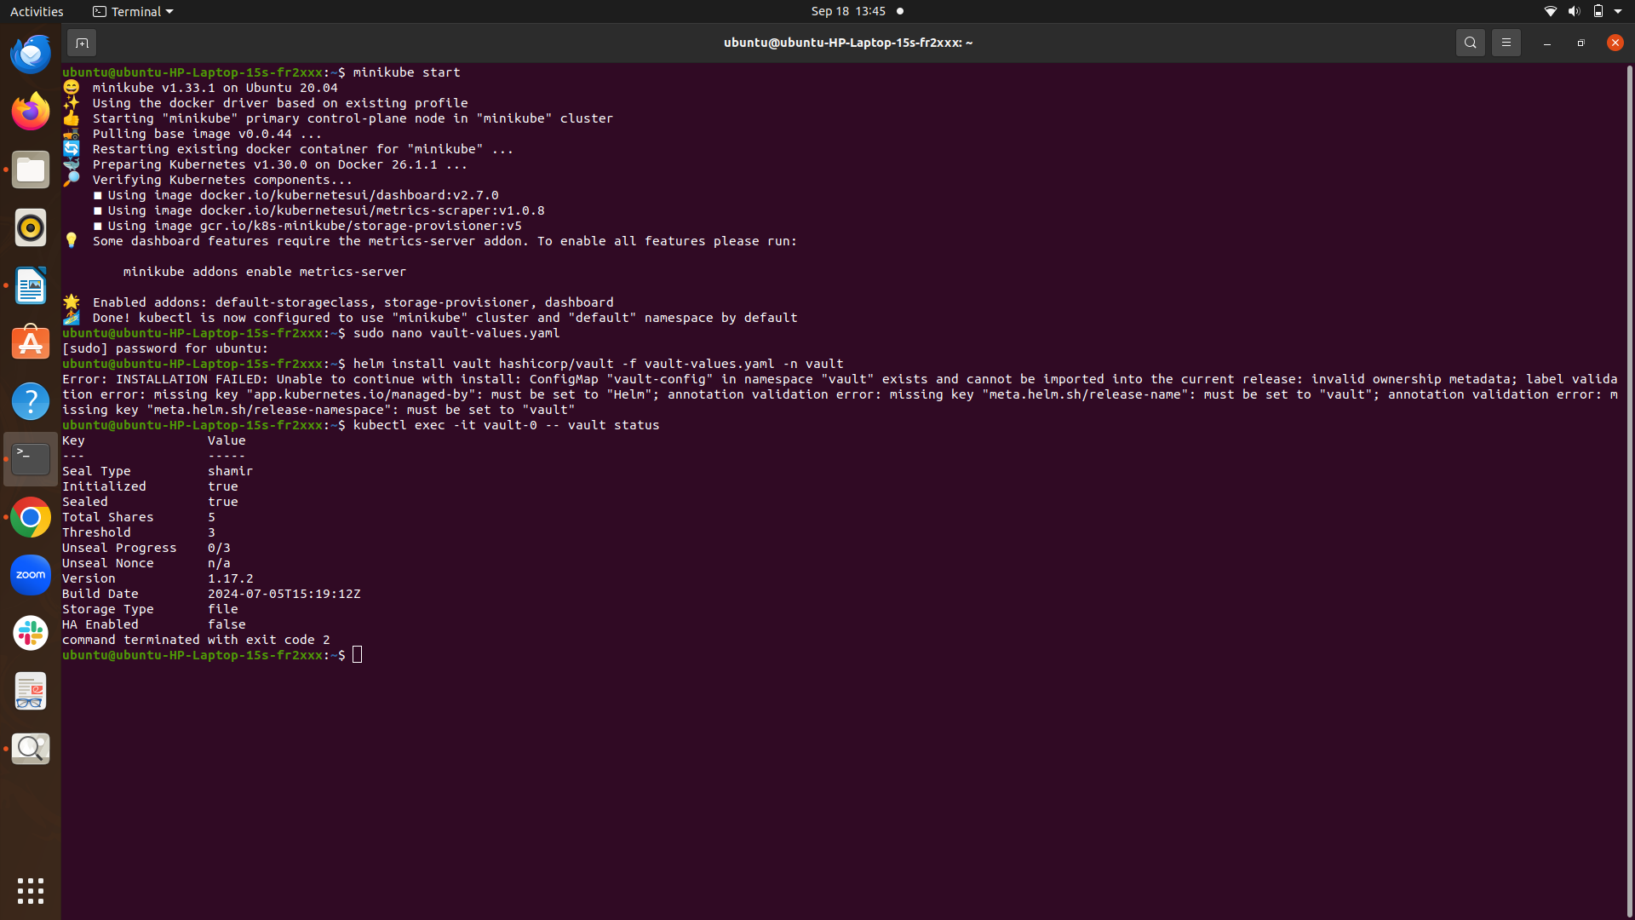
open minikube dashboard check
$minikube dashboard
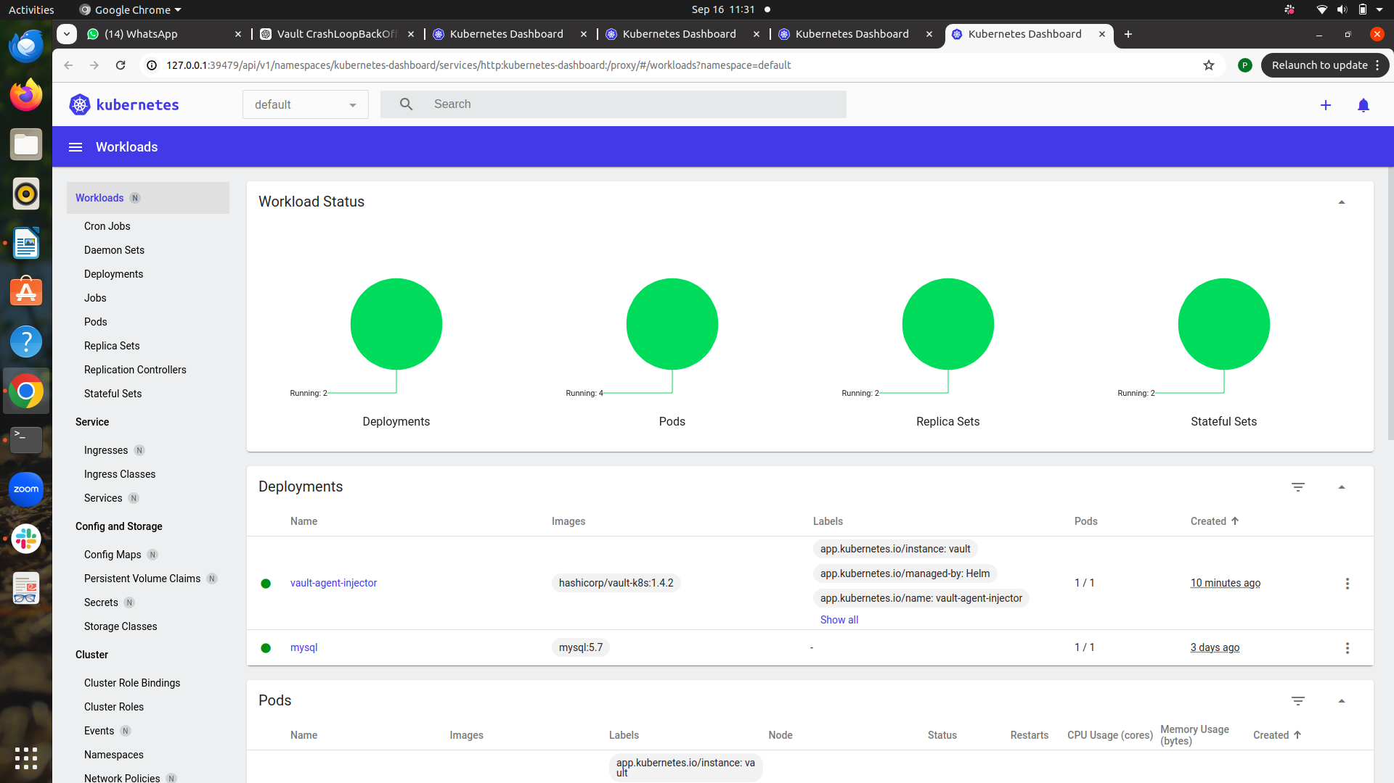
Step 4: Access Vault
1. Access Vault via port-forwarding:
$kubectl port-forward vault-0 8200:8200
2. Login to Vault:
export VAULT_ADDR='http://127.0.0.1:8200'
vault login <root-token>
OR
minikube ip:Nodeport of vault-ui-service
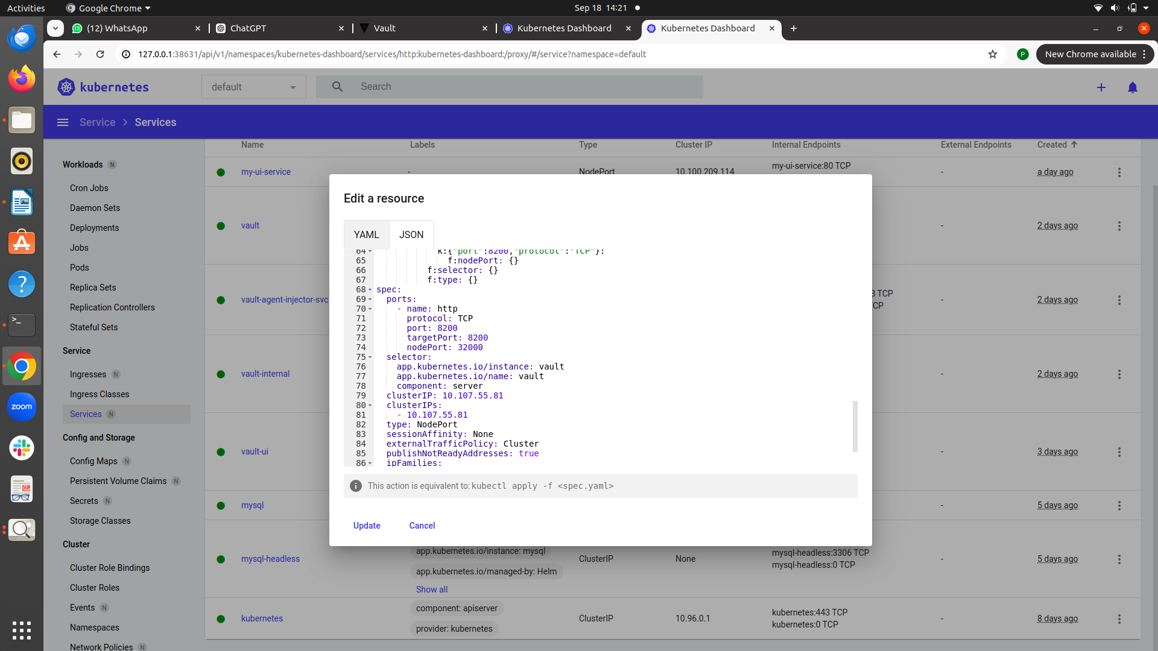
i.e http://192.168.49.2:32000/

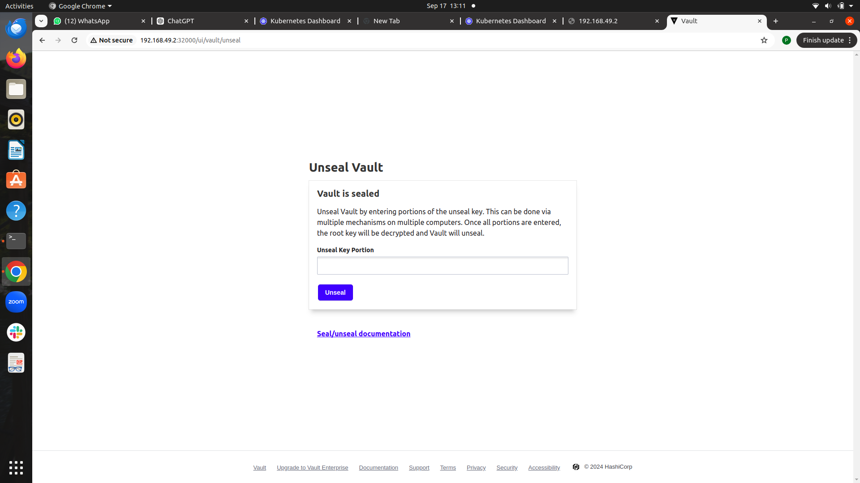
enter the 3 unseal keys then
enter root token then open the vault Dashboard

